Software Requirement Specifications
<News and Entertainment>



Submitted by
<Ahsan Sajjad (Roll No: F22BINFT1M01172)>

Submitted to
<Ms.Kainat>

Department of Information Technology
Faculty of Computing
The Islamia University of Bahawalpur

Summary
This Software Requirement Specification (SRS) document provides a detailed outline of the functionalities, structure, and operational requirements of the News and Entertainment Website. The purpose of the system is to provide users with up-to-date, reliable, and engaging news and entertainment content from multiple categories, including national news, international news, sports, technology, lifestyle, and entertainment.
The document outlines the system’s objectives, scope, user characteristics, system architecture, functional and non-functional requirements, and detailed use case descriptions. The website aims to become a digital platform where users can stay informed about daily life events, trending stories, and entertainment updates in a user-friendly way. The proposed system emphasizes accessibility, speed, usability, and efficient content management.

Table of Contents
1. Introduction 4
1.1. Purpose 4
1.2. Scope 4
1.3. Product Perspective 5
1.4. User Characteristics 6
1.5. Similar apps and systems/Literature Review 7
1.6. Proposed Technologies 11
2. Requirements 11
2.1. Function Requirements 12
2.1.1. Sign Up 12
2.2. Non-Functional Requirements 12
3. Use Cases and Flow of Processes 12
3.1. Use Case 1 13
4. References 14

- Introduction
The News and Entertainment Website is designed as a public web platform to deliver daily news, trending stories, and entertainment material in an organized and accessible manner. The goal is to create a centralized information hub similar to leading platforms such as BBC, CNN, Dawn News, etc., but with more personalized categories and simplified browsing features.
The system includes two major modules:
- User Module – for reading, browsing, and interacting with content.
- Admin Module – for content creation, editing, publishing, and system management.
This SRS document describes all components required for the system’s design and implementation.

  - Purpose
The purpose of this project is to develop a responsive and interactive online news portal that:
- Provides daily news and entertainment content.
- Allows users to browse categories and search articles.
- Enables admins to publish, update, and delete news.
- Ensures fast performance and high usability for all visitors.
The project aims to increase user engagement through a clean design, smooth navigation, and structured content delivery.
  - Scope
The scope of this project includes:

In-Scope
- User registration and login
- Displaying categorized news
- Viewing full news articles
- Searching through news
- Commenting or liking posts (optional)
- Admin dashboard for content management
- Uploading text, images, and videos in articles

Out-of-Scope
- Mobile application
- Live TV streaming
- Push notifications
- AI-generated summaries
- User-to-user interaction, messaging, forums
The current version focuses only on static news/article-based content.

  - Product Perspective
The News and Entertainment Website will function as a standalone web-based system.
The system fits into a typical web architecture containing:
- Frontend interface for users.
- Backend system for processing and managing data.
- Database server for storing news content, admin accounts, and user info.
It will interact only with its internal modules and does not require integration with external systems.

  - User Characteristics

1. General Users
- Age 15+
- Basic computer/mobile usage knowledge
- Visit the site to read news and entertainment content
- No technical background required

2. Admin / Content Manager
- Responsible for uploading, editing, deleting news
- Should have basic experience with CMS and web forms
- Trained to maintain accuracy of news

3. Super Admin (optional)
- Manages all admins
- Can approve or reject new admin accounts
- Can control site-wide settings
  - Similar apps and systems/Literature Review
Many well-known websites provide news and entertainment, such as:

1. BBC News
- Comprehensive news coverage
- High trust but lacks localized content

2. CNN
- Global news focus
- Heavy interface for slow internet users

3. Dawn News
- Strong local news reporting
- Limited entertainment content

4. BuzzFeed
- Entertainment-focused
- Less emphasis on authentic news

Identified Gaps
- Lack of combined news + entertainment platforms with simple interface
- Limited content personalization
- Some sites are too heavy for low bandwidth users
Our website aims to combine both information and entertainment in a lightweight interface.
  - proposed Technologies

Frontend
- HTML5
- CSS3
- JavaScript
- React.js

Backend
- Node.js (Express) or Django

Database
- MySQL / MongoDB

Other Tools
- Firebase or cPanel hosting
- GitHub for version control
- Requirements
The website will allow users to browse categorized news, read full articles, search topics, and interact with content. Admins will upload, update, delete, and manage news, multimedia, and categories.
  - Function Requirements

FR001 – User Sign Up
- Purpose: Allow new users to register.
- Users: General Users
- Input: Name, Email, Password, Phone
- Output: User account created

FR002 – User Login
- Purpose: Authenticate users to access profile-based features.
- Input: Email, Password
- Output: Access to user dashboard

FR003 – View News Categories
- Purpose: Allow users to browse news by category.
- Input: Category Selection
- Output: List of relevant news articles

FR004 – Read Full Article
- Purpose: Display detailed news content.
- Input: Click on article
- Output: Full article view

FR005 – Search News
- Purpose: Enable users to search content.
- Input: Search keywords
- Output: List of matching articles

FR006 – Admin Login
- Purpose: Allow admin access to dashboard
- Input: Username, Password
- Output: Admin dashboard

FR007 – Admin Add News
- Purpose: Allow admin to publish new articles
- Input: Title, Category, Image, Description
- Output: News published

FR008 – Admin Edit News
- Purpose: Modify existing news content
- Input: Updated content fields
- Output: Updated article stored

FR009 – Admin Delete News
- Purpose: Remove outdated or incorrect content
- Input: Delete request
- Output: Article removed

FR010 – Manage Categories
- Purpose: Admin can add/edit/delete categories

  - Non-Functional Requirements

1. Performance
- Must load pages within 3 seconds
- Must support 100+ concurrent users

2. Security
- Passwords encrypted
- Admin panel protected
- Protect against SQL injection

3. Usability
- Simple and clean UI
- Mobile responsive design

4. Reliability
- 99% uptime
- Auto backup of news

5. Scalability
- Should support increasing traffic

6. Maintainability
- Codebase modular
- Easy to update by developers

- Use Cases and Flow of Processes
Below are the major use cases of the system.

Use Case 1 – User Sign Up
ID: UC001
Name: Sign Up
Description: New users create an account
Actor(s): User
Precondition: User must not already have an account
Postcondition: New account created

Basic Flow
- User opens sign-up page
- User enters Name, Email, Password
- System validates input
- If valid → system creates new user
- System shows success message

Alternative Flow
- If email already used → show error
- If password is weak → request stronger password

Exceptions
- Database connection failed
- Server timeout

Use Case 2 – View News
ID: UC002
Actor: User
Basic Flow:
- User selects category
- System retrieves news
- System displays news list

Use Case 3 – Admin Add News
ID: UC003
Actor: Admin
Basic Flow:
- Admin logs in
- Admin selects “Add News”
- Admin fills details
- System validates
- System publishes news
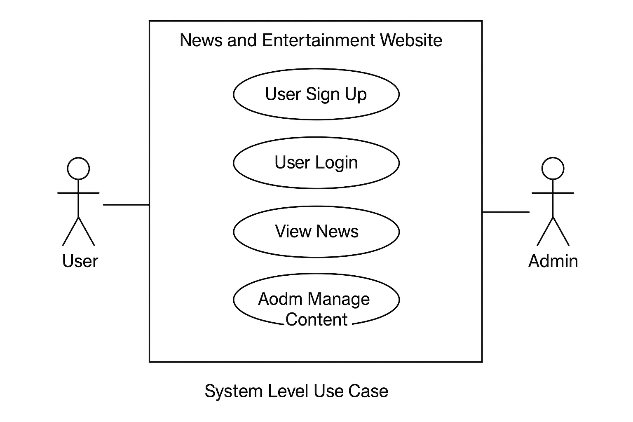

Activity Diagram (For Sign Up)
(Describe this in your SRS or draw in draw.io)
Steps:
Start → Enter Info → Validate Inputs → If valid? → Yes → Create Account → End
If no → Show Error → Back to form

Activity Diagram (For View News)
Start → Select Category → Fetch Data → Display News → End
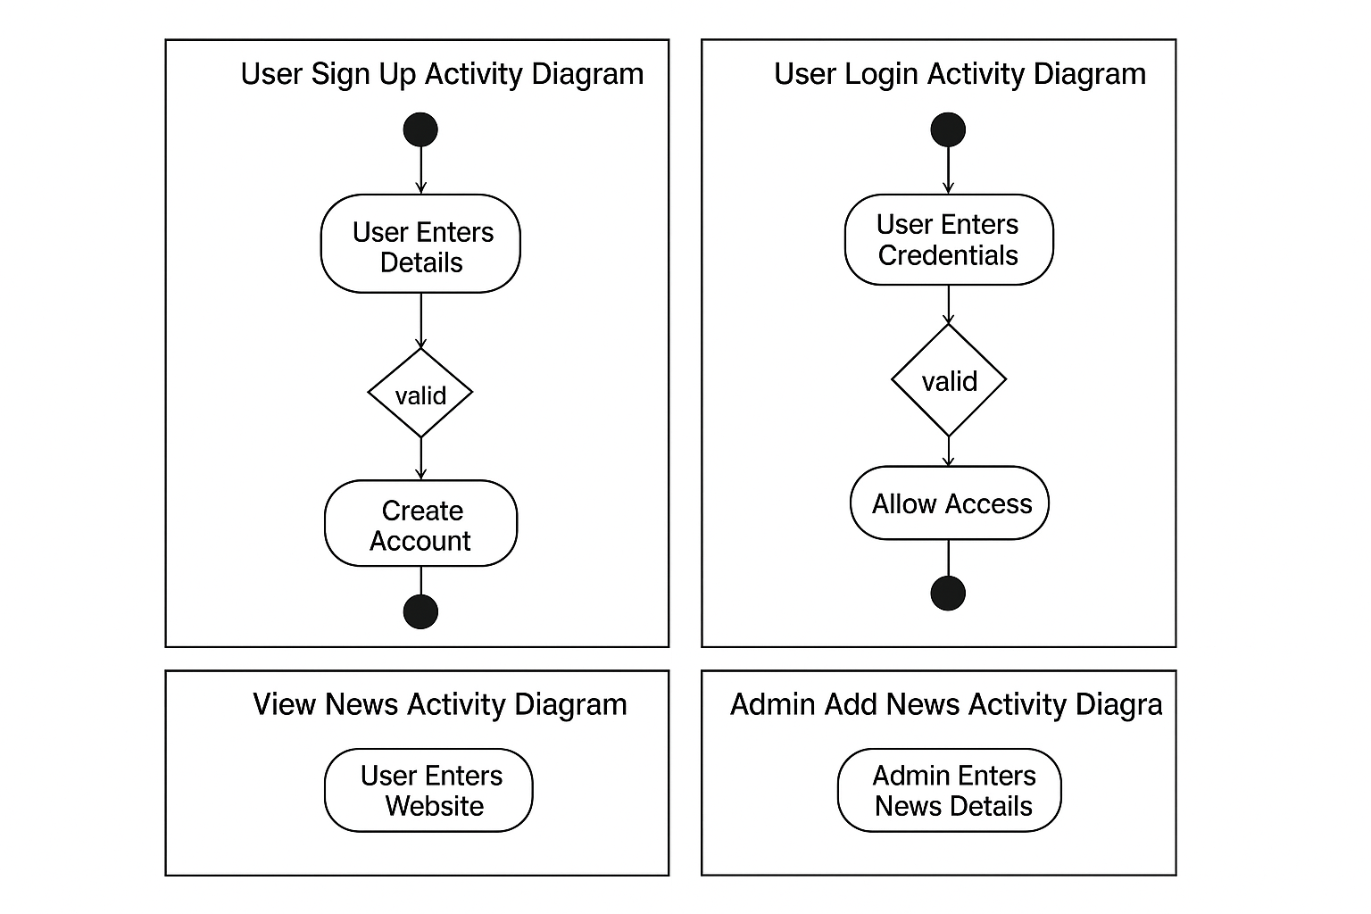

- References
[1] IEEE Software Engineering Standards.
[2] BBC News – Online News Portal.
[3] Dawn News – Pakistani News Portal.
[4] StackOverflow Documentation on Web Development.

